**Chapter 1**

**INTRODUCTION**

* 1. **About Car Rental System**

Car Rental System is a web based system for a company that rents out cars. This system enables the company to make their services available to the public through the internet and also keep records about their services.

The world has become a place where there is a lot of technological development; where every single thing done physically has been transformed into computerized form. Nowadays, people’s activities have been transformed into work done by computerized systems. One of which is the main target of this project which is about Car Rental System. The system of renting cars exist back in the previous years, were people rent cars for their personal reasons. Car renting is essential to many peoples’ plan to travel or move from one place to another for business purposes, tour, and visit or holidays, for these reasons Car renting is very helpful.

Many people became interested in the Car rental business and hence got involved. Car renting became more popular as years pass by. Today Car renting services is found all over the world, especially in the developed and developing countries. To make this service more popular and accessible to the public it has been transform into a web base system and connected to the internet were everyone can be able to have access to it.

**1.2 About XAMPP**

XAMPP is an easy to install Apache distribution containing MySQL, PHP and Perl. XAMPP is really very easy to install and to use - just download, extract and start.

It contains the following

* Apache 2.4.4
* MySQL 5.5.32
* PHP 5.4.16
* phpMyAdmin 4.0.4
* FileZilla FTP Server 0.9.41
* Tomcat 7.0.41

**Programming Language Used :**

* HTML
* CSS
* PHP
* PHP My Admin

**1.3 About SQL**

Structured Query Language (**SQL**) is a standard computer language for relational database management and data manipulation. **SQL** is used to query, insert, update and modify data.

SQL statements are categorized into four different type of statements, which are

1. DML (DATA MANIPULATION LANGUAGE)
2. DDL (DATA DEFINITION LANGUAGE)
3. DCL (DATA CONTROL LANGUAGE)
4. TCL (TRANSACTION CONTROL LANGUAGE)

**DML**  
In Data Manipulation Language (DML), we have four different SQL statements.

1. **SELECT**  
   Select statement is used to select the collection of records from the table, which is based on some condition.
2. **INSERT**Insert statement is used to insert the set of values into the table.
3. **UPDATE**Update statement is used to update the existing values in the table, which is based on some condition.
4. **DELETE**Delete statement is used to delete the existing record in the table, which is based on some condition.

**DDL**  
In Data Definition Language (DDL), we have three different SQL statements.

1. **CREATE**  
   Create statement is used to create the new table in an existing database.
2. **ALTER**  
   Alter statement can add a column, modify a column, drop a column, rename a column or rename a table.
3. **DROP**  
   SQL DROP TABLE statement is used to remove a table definition and all the data, indexes, triggers, constraints and permission specifications for the table.

**DCL**  
In Data Control Language (DCL), it defines the control over the data in the database. We have two different commands, which are

1. **GRANT**  
   Grant is allowed to do the specified user to the specified tasks.
2. **REVOKE**  
   It is used to cancel previously granted or denied permissions.

**TCL**  
In Transaction Control Language (TCL), the commands are used to manage the transactions in the database. These are used to manage the changes made by DML statements. It also allows the statements to be grouped together into logical transactions.

1. **COMMIT**Commit command is used to permanently save any transaction into the database.
2. **ROLLBACK**  
   Rollback command is used to restore the database for the last committed state. It’s also used with save point to jump to the save point.
3. **SAVEPOINT**  Save point command is used to temporarily save a transaction, so that you can roll back to that point whenever necessary.

**Chapter 2**

**SYSTEM REQUIREMENTS**

The package is designed such that users with a computer having minimum configuration can use it, which does not require complex packages.

The package requires simple PC configuration as follows: -

**2.1 Software Requirements**

Operating System - Windows 7 & above

Language Tool - HTML, CSS, PHP

Software - XAMPP

Database - MYSQL

Documentation Tool - MS-Word

**2.2 Hardware Requirements**

Processor - Pentium 4 & above

Hard Disk Capacity - 2GB

RAM - 512MB

**Chapter 3**

**SYSTEM DESIGN**

**3.1 ER Diagram**

It is graphical representation of an information system that depicts the relationship among ople, objects, places, concepts or events within that system.

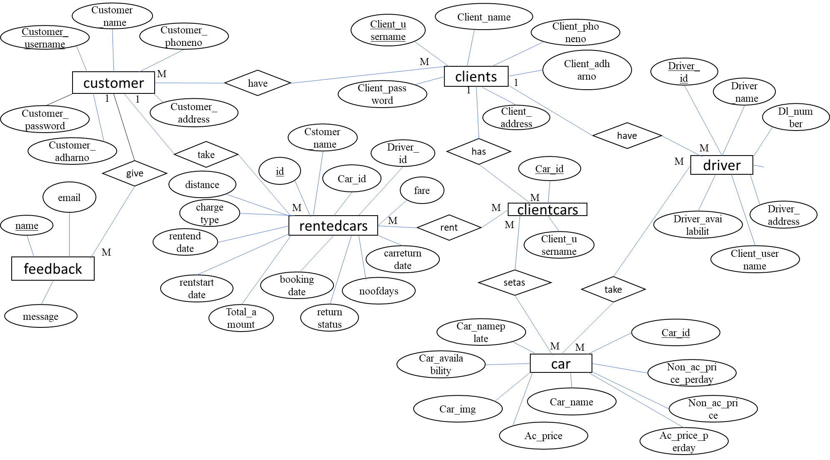

**3.2 Schema Diagram**

It is a skeleton structure that represents the logical view of the entire database. It defines how the data is organised and how the relations among them are associated.

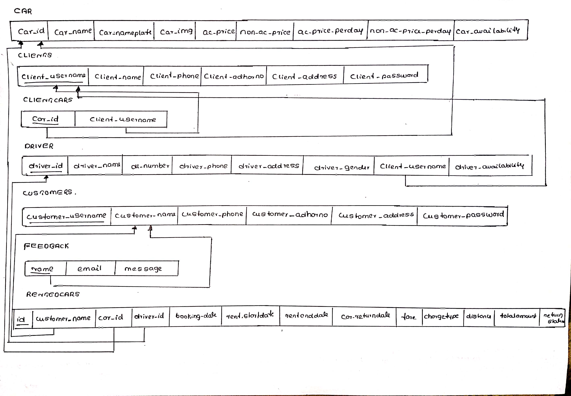

**3.3 Table Content**

**3.3.1 Cars Table**

|  |  |  |  |  |
| --- | --- | --- | --- | --- |
| **Field Name** | **Data type** | **Size** | **Constraint** | **Description** |
| Car_id | Int | 20 | Primary key | Stores car id |
| Car_name | Varchar | 50 | Not null | Stores car name |
| Car_nameplate | Varchar | 50 | Not null | Stores car nameplate |
| Car_img | Varchar | 50 | NA | Stores car image |
| Ac_price | Float | 20 | Not null | Stores ac price |
| Non_ac_price | Float | 20 | Not null | Stores non ac price |
| Ac_price_perday | Float | 20 | Not null | Stores ac price per day |
| Non_ac_price_perday | Float | 20 | Not null | Stores non ac price per day |
| Car_availability | Varchar | 10 | Not null | Stores car availability |

**3.3.2 Owner Table**

|  |  |  |  |  |
| --- | --- | --- | --- | --- |
| **Field Name** | **Data type** | **Size** | **Constraint** | **Description** |
| Owner_username | Varchar | 50 | Primary key | Stores Owner username |
| Owner _name | Varchar | 50 | Not null | Stores Owner name |
| Owner _phone | Varchar | 15 | Not null | Stores Owner phone no |
| Owner _adharno | Varchar | 12 | Not null | Stores Owner adhar no |
| Owner _address | Varchar | 50 | Not null | Stores the Owner taddress |
| Owner _password | Varchar | 20 | Not null | Stores the Owner password |

**3.3.3 Ownercars Table**

|  |  |  |  |  |
| --- | --- | --- | --- | --- |
| **Field Name** | **Data type** | **Size** | **Constraint** | **Description** |
| Car_id | Int | 20 | Primary key | Stores car id |
| Owner _username | Varchar | 50 | Foreign key | Stores Owner username |

**3.3.4 Customers Table**

|  |  |  |  |  |
| --- | --- | --- | --- | --- |
| **Field Name** | **Data type** | **Size** | **Constraint** | **Description** |
| Customer_username | Varchar | 50 | Primary key | Stores customer username |
| Customer_name | Varchar | 50 | Not null | Stores customer name |
| Customer_phone | Varchar | 10 | Not null | Stores customer phone |
| Customer_adharno | Varchar | 15 | Not null | Stores customer adhar number |
| Customer_address | Varchar | 50 | Not null | Stores customer address |
| Customer_password | Varchar | 20 | Not null | Stores customer password |

**3.3.5 Driver Table**

|  |  |  |  |  |
| --- | --- | --- | --- | --- |
| **Field Name** | **Data type** | **Size** | **Constraint** | **Description** |
| Driver_id | Int | 20 | Primary key | Stores the driver id |
| Driver_name | Varchar | 50 | Not null | Stores the driver name |
| Dl_number | Varchar | 50 | Not null | Stores the driver dl number |
| Driver_phone | Varchar | 10 | Not null | Stores driver phone no |
| Driver_address | Varchar | 50 | Not null | Stores driver address |
| Driver_gender | Varchar | 10 | Not null | Stores driver gender |
| Owner _username | Varchar | 50 | Foreign key | Stores client username |
| Driver_availability | Varchar | 10 | Not null | Stores driver availability |

**3.3.6 Rentedcars Table**

|  |  |  |  |  |
| --- | --- | --- | --- | --- |
| **Field Name** | **Data type** | **Size** | **Constraint** | **Description** |
| Id | Int | 100 | Primary key | Stores the id |
| Car_id | Int | 20 | Foreign key | Stores car id |
| Driver_id | Int | 20 | Foreign key | Stores driver id |
| Booking_date | Date | date | Not null | Store the car booking date |
| Rent_start_date | Date | date | Not null | Stores the car rent start date |
| Rent_end_date | Date | date | Not null | Stores the car rent end date |
| Car_return_date | Date | date | Not null | Stores the car return date |
| Fare | Double | 50 | Not null | Stores the fare |
| Charge_type | Varchar | 25 | Not null | Stores the type of charge |
| Distance | Double | 50 | Not null | Stores the distance |
| No_of_days | Int | 50 | Not null | Stores the no of days |
| Total_amount | Double | 50 | Not null | Stores the total amount |
| Return_state | Varchar | 10 | Not null | Stores return status |

**3.3.7 Feedback Table**

|  |  |  |  |  |
| --- | --- | --- | --- | --- |
| **Fieldname** | **Datatype** | **Size** | **Constraint** | **Description** |
| Name | Varchar | 50 | Primary key | Stores the name |
| Email | Varchar | 50 | Not null | Stores the email |
| Message | Varchar | 500 | Not null | Stores the message |

**Chapter 4**

**IMPLEMENTATION**

Implementation is stage of project where the theoretical design is turned into a working system. Customer can login into account using email and password if that user is already registered. New customer can register using Register option. The customer can reserve a car and also view its details.

**4.1 Module Implementation**

Our project includes following modules

**4.1.1. Owner Module**

Owner:Owner can rent his car.and he can add cars and drivers

**4.1.2. Customer Module**

Customer: Customer can view the website and check out the available cars and he/she can book the car of their choice and also, they can book a driver for that car.

**Chapter 5**

**RESULTS**

**5.1 Screen Shots**

**5.1.1 Home page**

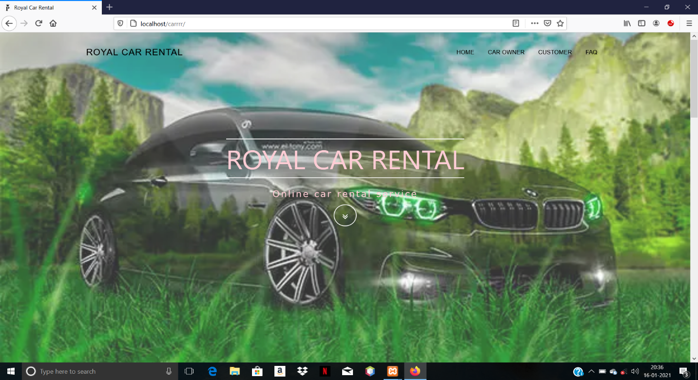

**5.1.2 Login page for Car Owners and Customers**

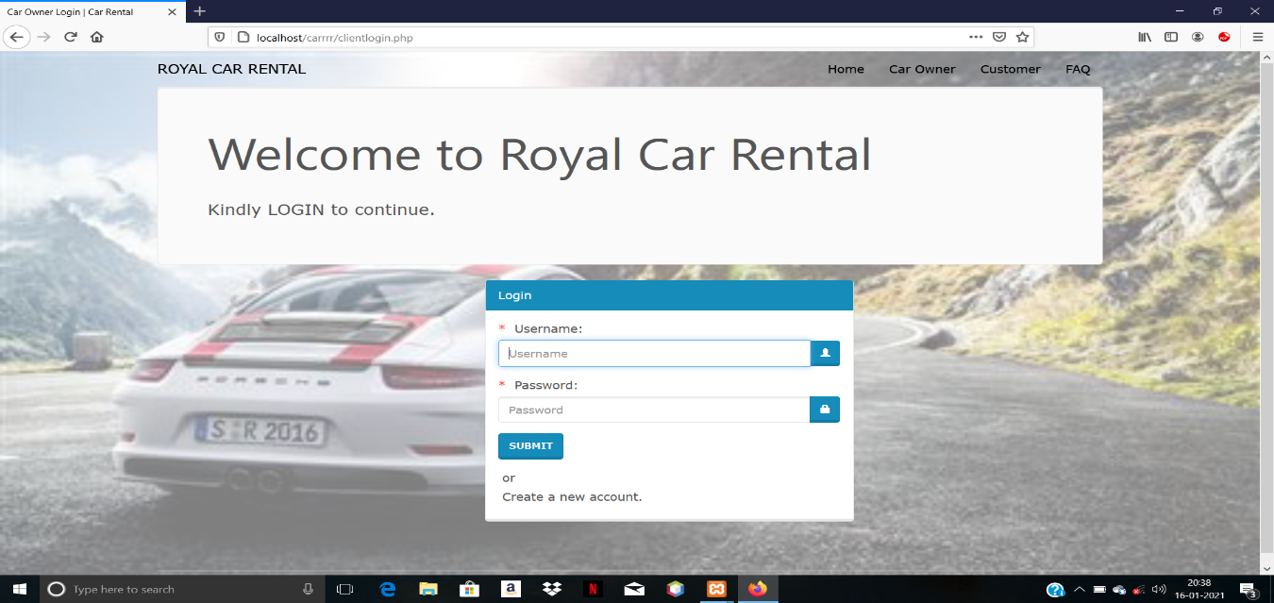

**5.1.3 Signup page for Customers and Car Owners**

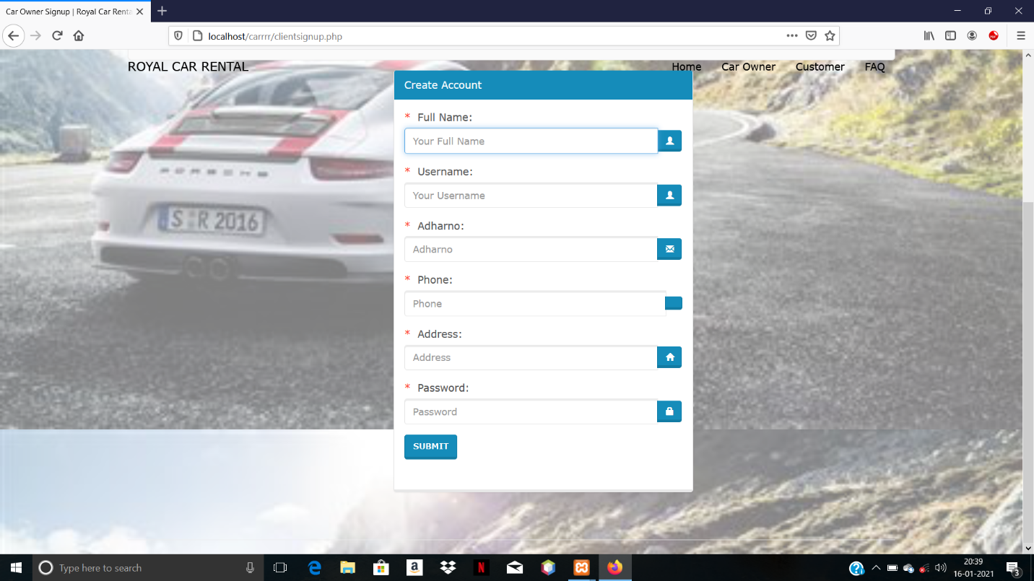

**5.1.4 Available Cars Page**

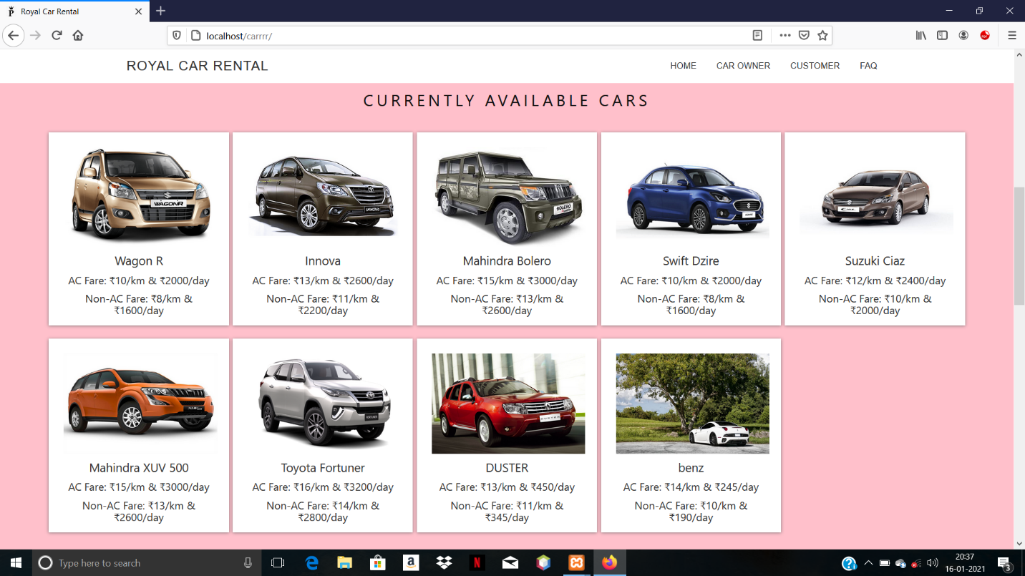

**5.1.5 Car Booking Page**

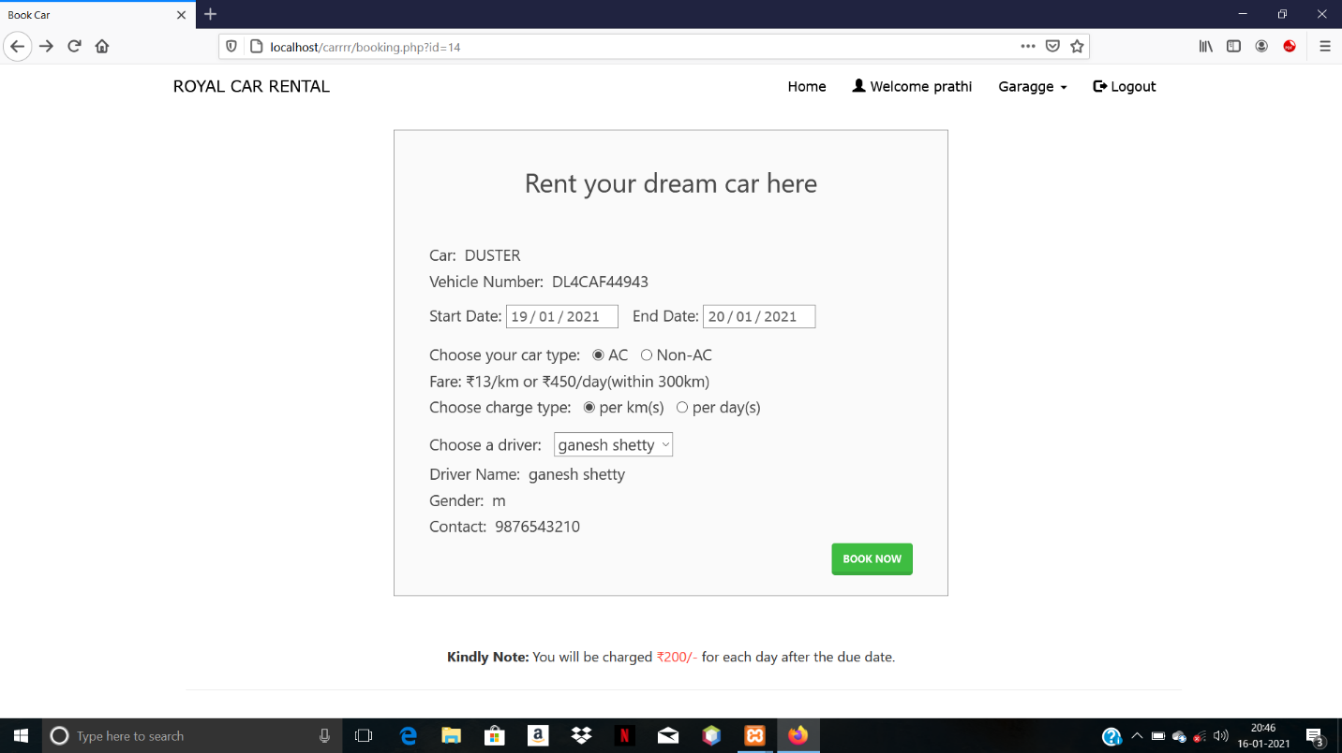

**5.1.6 Booking Page for Customers**

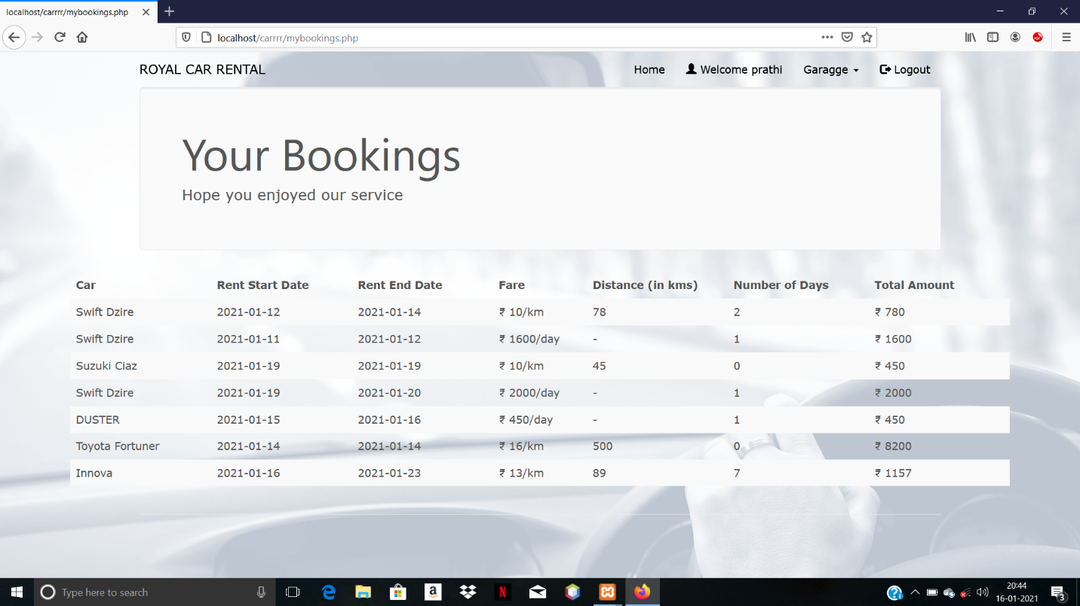

**5.1.7 Booking Confirmed page**

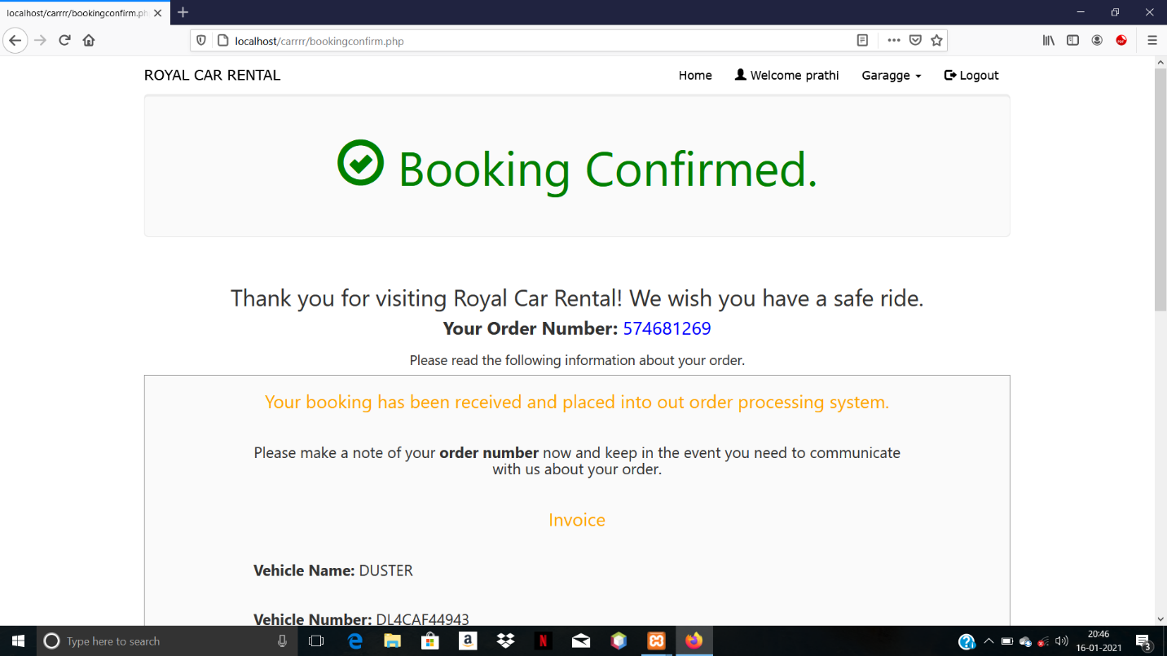

**5.1.8 Car returned page**

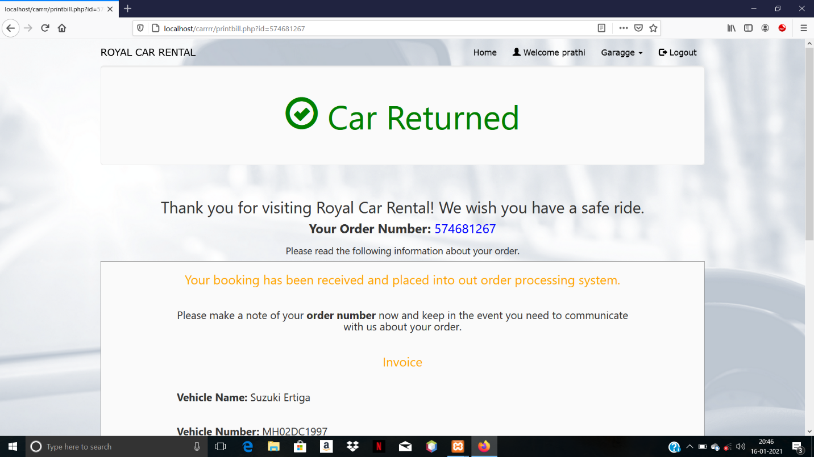

**5.1.9 Add Car page for Car Owners**

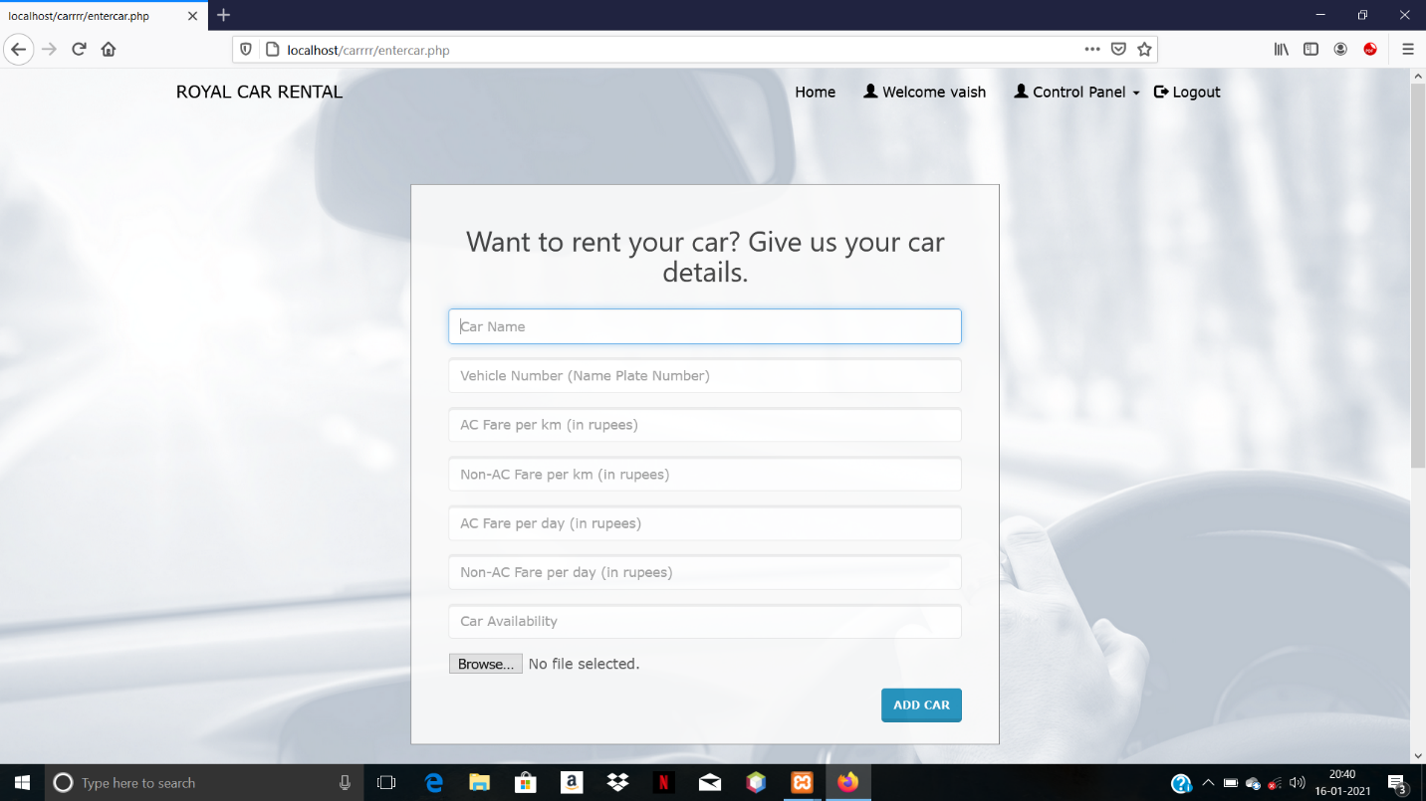

**5.1.10 My Cars page**

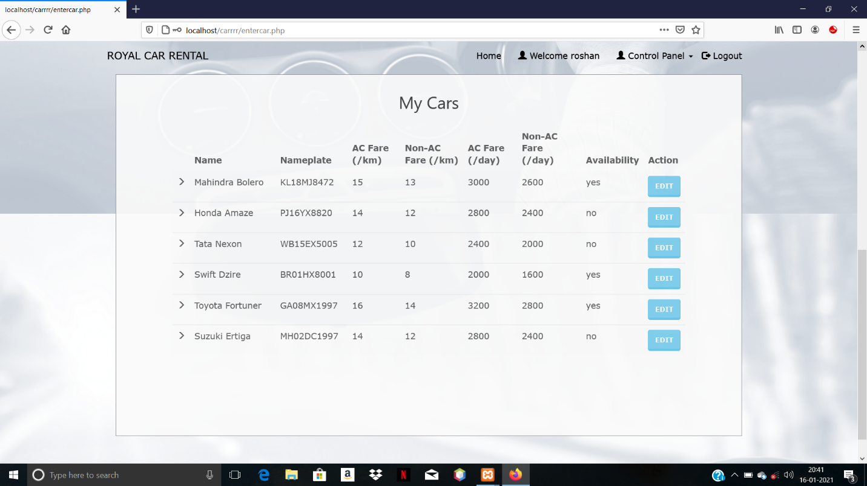

**5.1.11 Add Driver Page**

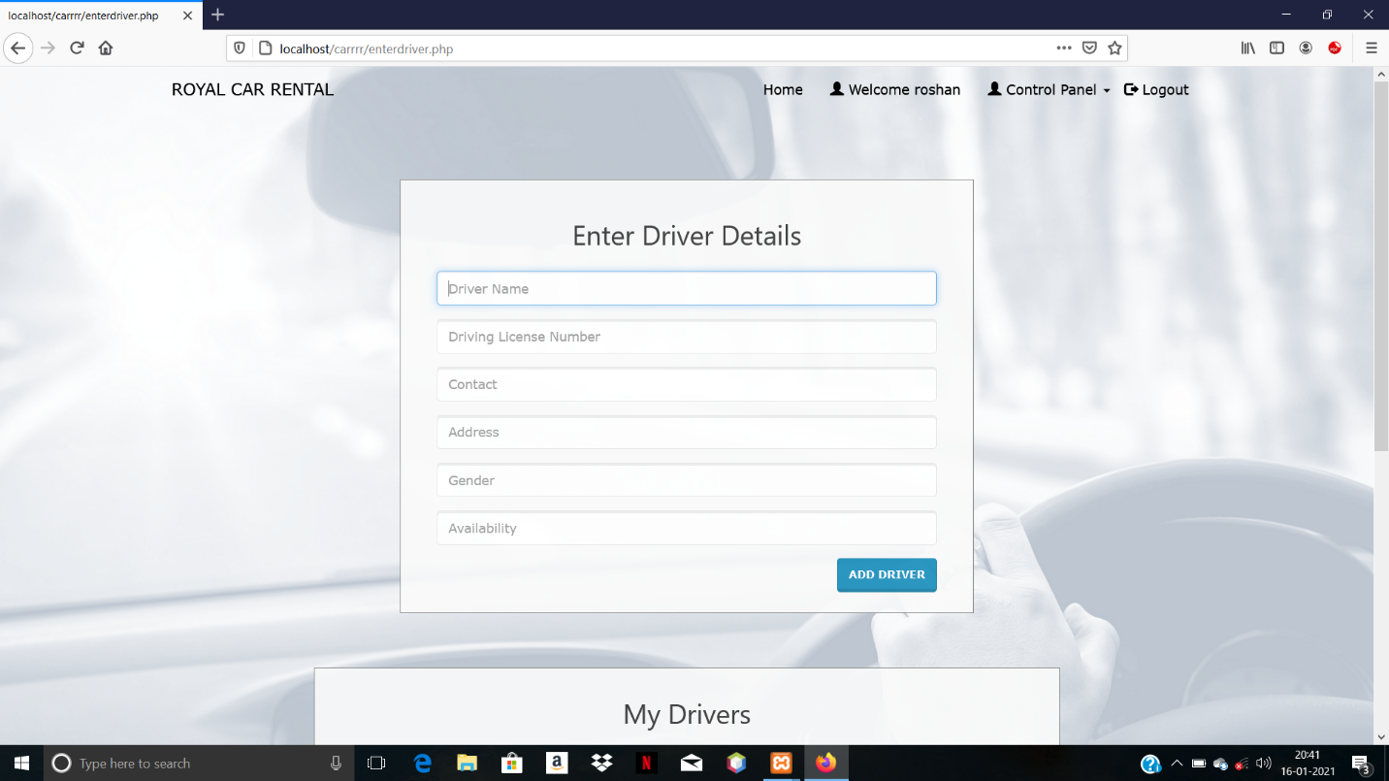

**5.1.12 My Driver page**

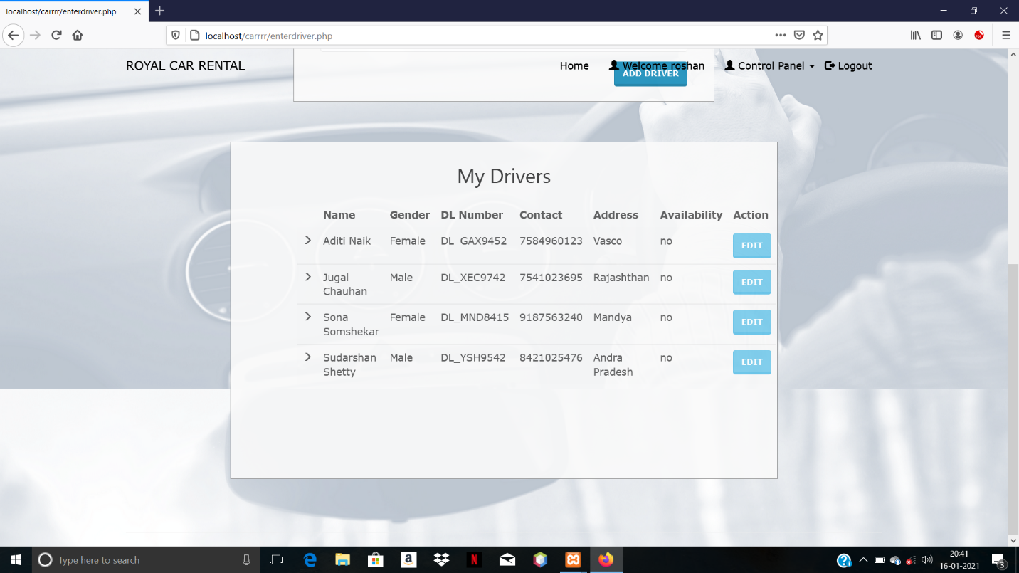

**5.1.13 Feedback page**

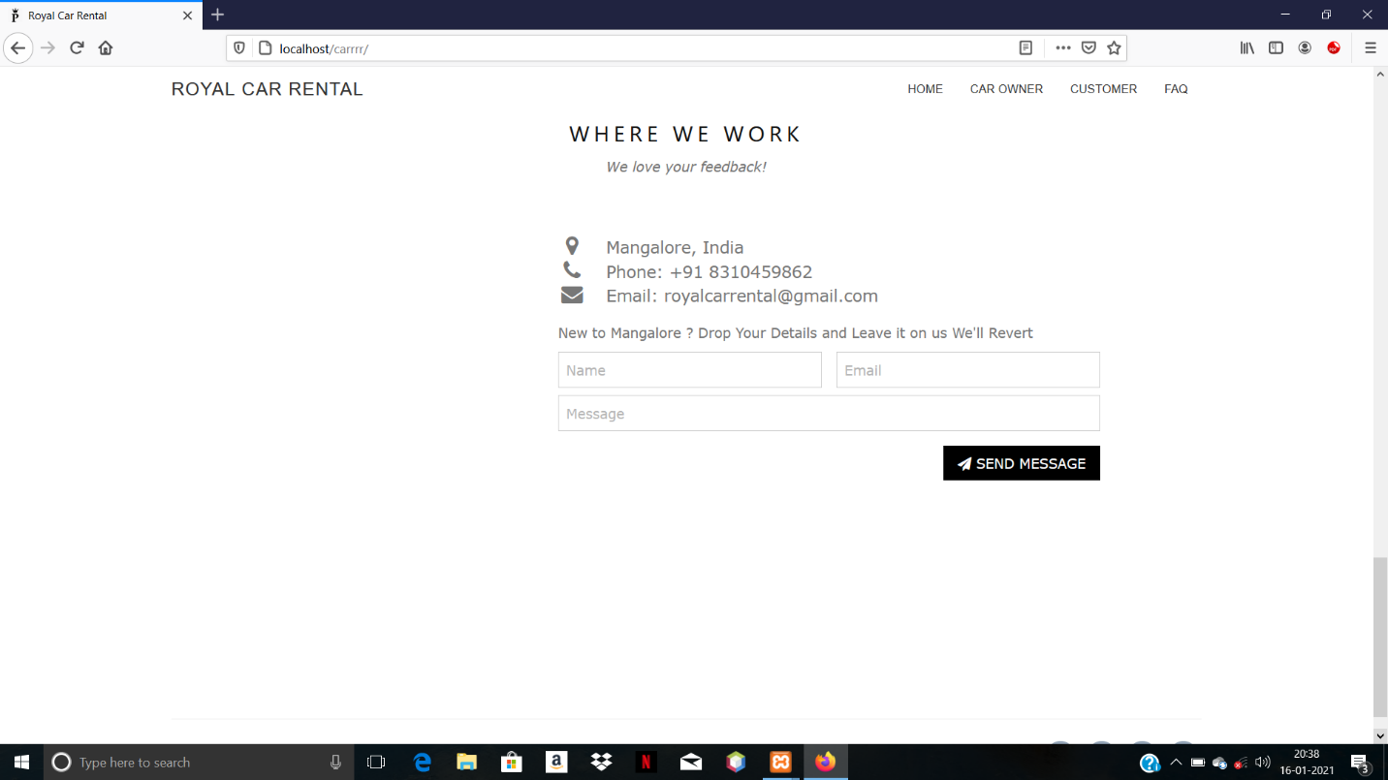

**CONCLUSION**

In conclusion, the Car Rental System will be able to serve as a web base application when it is finally developed, where these small upcoming companies can make use of it to publish their services in a wide range and also help the company to manage their service more effectively. On the other hand, it will enable customers to freely make their desire choice more freely and interactively.

**REFERENCES**

1. Edward Angel, Interactive Computer Graphics A Top-Down Approach Using OpenGL, 5th edition, Dorling Kindersley India Pvt. Ltd., UP, India, 2009.
2. Computer Graphics Using OpenGL– F.S. Hill, Jr. 2nd Edition, Pearson 1. Education, 2001.
3. Computer Graphics– James D Foley, Andries Van Dam, Steven K Feiner, John F Hughes, Addison-wesley 1997.
4. Computer Graphics - OpenGL Version – Donald Hearn and Pauline Baker, 2nd Edition, Pearson Education, 2003.